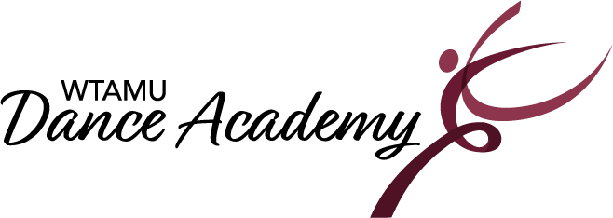

2022-2023 Class Schedule

Studio 154 | Monday | Tuesday | Wednesday | Thursday
4:00-5:00 pm  Teacher:  Assistant: | Ballet/Jazz  (6-8 yrs.)  Lorelai Stager | Ballet/Tap  (3-5 yrs.)  Abbi Roe  Lorelai Stager | Jazz  (9-12 yrs.)  Sierra Cross | Tap/Musical Theatre Dance  (6-8 yrs.)  Abbi Roe
5:00-6:00 pm  Teacher:  Assistant: | Ballet  (9-12 yrs.)  Kaleigh De La Cruz | Tap  (9-12 yrs.)  Sierra Cross  Kaleigh De La Cruz | Hip Hop  (9-12 yrs.)  Sierra Cross | Musical Theatre Dance  (9-12 yrs.)  Abbi Roe

Studio 154 | Saturday
10:00-11:00 am  Teacher:  Assistant: | Ballet/Tap  (3-5 yrs.)  Abbi Roe

Registration: The WT Dance Academy uses the online software, Circuitree for registering. There is a $10.00 non-refundable registration fee per student to enroll.
Parents/Guardians may register their participant online starting August 1, 2022! Registration is on-going for anyone that would like to add a class in addition to current registered classes. The last day to make changes and to register for the 2022-2023 year is December 2nd 2022.
For questions, please contact the Dance Academy office at 806-651-2820 or danceacademy@wtamu.edu. The academy office is open when classes are in session. The office is adjacent to Studio 154.
Class Descriptions
All classes are 1 hour in length and held in Dance Studio 154 located in Mary Moody Northen Hall on the West Texas A&M University campus.

Ballet/Tap 3-5yrs. -This popular combo class consists of fun, nurturing, engaging, movement exercises using basic steps to introduce dance terminology, all while encouraging creativity and group interaction. Two routines will be taught and presented in the Academy’s annual recital in May.

Ballet/Jazz 6-9yrs. – This exciting combo class will focus on the fundamentals of ballet and jazz with more coordination and sequence-related technique exercises implemented at the appropriate level. Two routines will be taught and presented in the Academy’s annual recital in May.

Tap/Musical Theatre Dance- Embrace your inner Broadway star in this combo class while developing skills also in Tap Dance! Exercises that develop coordination and rhythm while improving timing and agility are the focus of this class. Two routines will be taught and presented in the Academy’s annual recital in May.

Ballet 9-12yrs. –Ballet is the foundation of all dance forms. This class will focus on terminology and classical technique in which develop coordination, strength, balance, proper alignment, and flexibility. One routine will be taught and presented in the Academy’s annual recital in May.

Jazz 9-12yrs. – This class is an excellent experience for the dancer who is interested in further strengthening their jazz dance technique as well as develop a solid technical base and perform innovative choreography. One routine will be taught and presented in the Academy’s annual recital in May.

Tap 9-12yrs. –Tap is a popular genre of American theatrical dance distinguished by percussive footwork. Dancers develop a sense of rhythm and musicality and perform progressions to increase technical skills. One routine will be taught and presented in the Academy’s annual recital in May

Musical Theatre Dance 9-12yrs. –is a jazz-based class filled with Broadway style dancing and music. This high-energy class incorporates and explores presentational elements as well as learn one routine to be taught and presented in the Academy’s annual recital in May.

Hip Hop Dance 9-12yrs.- This class is a fun, energetic and expressive dance genre using the latest dance moves set to age-appropriate hip hop music for kids. Hip Hop encompasses a wide range of street dance and freestyle improvisation is explored.

